**Allah, Kouakou Herve,**

**Andrade, Joel,**

**Cisse, Serigne Cheikh Modou Kara**

**Due Date: December 19, 2021**

**Subject:**

**Do opportunity disparities exist among racial groups in New York City? Case study of employment opportunities in relation to healthcare coverage, education in a health cycle in 2019.**

Abstract:

The NYC Community Health Survey (CHS) is an annual survey that has provided key health surveillance data to the New York City Department of Health and Mental Hygiene (DOHMH) since 2002. The survey covers approximately 10,000 residents across New York City each year. From the inception of the survey, the annual data were designed to be analyzed at the level of the United Hospital Fund (UHF) neighborhoods, which are 42 geographic areas of aggregated ZIP Codes. Survey data collection at the UHF level is appealing because survey respondents generally know the ZIP Code that they live in, and therefore survey data can be aggregated into neighborhoods composed of multiple ZIP Codes that have enough respondents to generate reliable estimates. This CHS 2019 covers 8803 observations with 152 variables, of which some are binary, logical or continuous. CHS 2019 does not segregate the population sample by zip codes in 2019, but neighborhoods instead. However, it demonstrates the level of poverty line based on a National Standard. The neighborhood level data have enabled the Health Department in the ensuing years to identify unique health challenges within neighborhoods and highlight disparities between neighborhoods. By highlighting neighborhoods, new variables such as the helpfulness of neighbors have been assessed. The data has provided the basis for various targeted interventions. Although collecting data at the level of 42 neighborhoods is valuable, there may be a substantial variation in health conditions within neighborhoods that cannot be captured at the coarser neighborhood level when the neighborhoods used for analysis have an average of 200,000 residential adults. By using the CHS2019, we argue that there is a strong relationship between education and employment opportunities and healthcare coverage and body mass index, based on nutrition. Most importantly, we strongly argue that neighborhood factors are deeply related to race, based on income and community support. In the case of NYC, there are surely disparities among social groups mainly Blacks or African Americans and Hispancs ( Latinos being at the bottom of income disparities) , but being leading groups of the Healthcare coverage provided by the Federal or State services ( Medicaid, food stamps). Those factors seriously influence the food habits of citizens, impacting them on their body mass index (BMI), mood and behavior as well as their social networks or neighborhoods.

Variables used for demonstration:

Several data gathering projects have made health estimates at the level as small as census tracts, as public health professionals seek information about increasingly smaller areas. Understanding areas of highest need is a key goal of public health, and estimates at smaller geographies, or of subpopulations, are needed to provide this information so that interventions can be appropriately targeted. For example, the variable “***imputed_neighpovgroup4_1418***” related to the following question “ ***Neighborhood poverty; percent of zip code population living below 100% FPL per American Community Survey, 2014-2018***” and is based on the “ *Standard Agency area-based poverty measure, based on % of population in respondent’s zip code living below 100% FPL per American Community Survey 2014-2018, with imputation of missing cases”*.( CHS 2019 Codebook, pg 34).

In our CHS 2019, a new variable has been added to refer to “***newgenderid19”*** referring to a somewhat group. It turns the variable intially binary variable “gender” , referring to males or females into a wider bracket with new sexual orientations:

**1=Cisgender man**

**2=Cisgender woman**

**3=Transgender man**

**4=Transgender woman**

**5=Non-binary person, assigned male at birth**

**6=Non-binary person, assigned female at birth**

**7=Another gender identity, assigned male at birth**

**8=Another gender identity, assigned female at birth**

**.d=Don’t know**

Survey designs require sample sizes to be sufficiently large to yield direct estimates that are statistically reliable in small areas or subpopulations. For example, CDC recommends not reporting direct estimates based on a sample size of fewer than 50 people in the nationwide.

Behavioral Risk Factor Surveillance System (BRFSS) as we studied in class for Lab 7. For this reason, NYC DOHMH has not produced ZIP Code-level direct estimates of single years of data. The challenge of unreliable estimates could be resolved with larger sample sizes, however, increasing sample sizes in small areas is costly.

Methodology:

All credit belongs to New York City Department of Health and Mental Hygiene (DOHMH) who applied survey weights to directly observed estimates at the ZIP Code level and neighborhoods. Direct estimation by aggregation takes advantage of the continuous data collection of the CHS, and is similar to the approach taken by the American Community Survey (ACS) as we studied since the beginning of this semester. Our study aims to understand the tradeoff of racial implications based on factors such as general health conditions (“***generalhealth***”) , insurance coverage ***(“insure5”***), type of nutrition based on income means or food habits ( “***nutrition46”***) and the poverty line (“***imputed_povertygroup”***) and employment (“***employment***”). We only based our assumptions on the CHS 2019 without being biased and ran OLS regressions in order to substantiate our hypotheses. We assume that individuals invest in themselves through education, training and health. The goal is to increase earnings. But we cannot confirm if the current conditions of Coronavirus with its array of variants can facilitate our predictions. Also, we believe that health status is a productive good which produces healthy days. This data mentions various mood sentiments (“ mood1, mood2, mood3, mood4…), which are not the focus of our research. We do predict the relevance of the health status based on age, nutrition factors, levels of income, education, gender and neighborhoods. We argue also that Education improves efficiency in production, thus education matters to choices of health coverage based on employment, health insurance options, and so on. We argue also that there is a relationship between the labor-nutrition trade-off with respect to allocation of employment and health coverage to wage-earning activities.

This working data set is called CHS2019 and provides sample code to use when analyzing survey data. There are 8,803 observations and 152 variables in the dataset. The stratification (nesting) variable is strata and this survey data needs to be analyzed using a special procedure in SAS. We have imported the data set as SAS in R Studio. We want to study how individuals in New York City allocate their resources to produce Health, health insurance correlated to the roles of age, housing location and education. We assume that Individuals invest in themselves through education, training and health. The goal is to increase earnings. But we cannot confirm that current conditions. Also, we believe that Health insurance is a productive good which produces healthy days. This data mentions mood sentiments, which are not the focus of our research. We do predict the relevance of health status based on age, levels of income, education, gender and neighborhoods. We argue also that Education improves efficiency in production, thus education matters to choices of Health coverage, Health insurance options, and so on. We argue also that there is a relationship between the labor-leisure trade-off with respect to allocation of employment to wage-earning activities.

We focused on three major age groups: Group 1( 18 to 24 years for 654). Group2 ( 24 -44 years for 3,135 respondents ) and group 3 ( 45 to 64 years for 2,819 respondents).

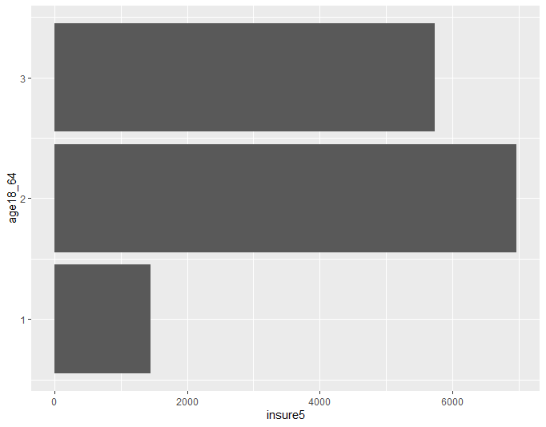

library(standardize)

library(Matrix)

library(MatrixCorrelation)

library(stringi)

library(stringr)

library(ggplot2)

library(ggplot.multistats)

library(ggplotAssist)

library(tidyverse)

library(tidyr)

library(tidyselect)

library(shiny)

library(shinyAce)

library(shinyWidgets)

library(standardize)

library(StandardizeText)

library(randomForest)

library(randomForestExplainer)

library(stargazer)

attach(chs2019_public)

length(chs2019_public)

list(chs2019_public)

summary(chs2019_public$generalhealth)

We certainly needed to clean up the data and create new variables ( in bold) that would focus on our study and facilitate running ordinary least squares (OLS). OLS is a type of linear least squares method for estimating the unknown parameters in a linear regression model. Some variables are self-explanatory and others have been explianed. Also, several packages were needed to guarantee that RStudio would perform the commands and somewhat generate outputs for explanation.

**HealthyGroup** <- as.factor(as.numeric(generalhealth == 1 | generalhealth ==2 | generalhealth ==3))

table(HealthyGroup)

str(chs2019_public)

**ExcellentHealth** <- as.factor(as.numeric(generalhealth ==1))

table(ExcellentHealth)

**VeryGoodHealth** <- as.factor(as.numeric(generalhealth ==2))

table(VeryGoodHealth)

**GoodHealth** <- as.factor(as.numeric(generalhealth ==3))

table(GoodHealth)

**FairHealth** <- as.factor(as.numeric(generalhealth ==4))

table(FairHealth)

**PoorHealth** <- as.factor(as.numeric(generalhealth ==5))

table(PoorHealth)

**Demographic** <- as.factor(as.numeric(chs2019_public$age18_64 >0))

summary(Demographic)

table(Demographic)

**BlackPeoples** <- as.factor(as.numeric(newrace ==2))

table(BlackPeoples)

**HispanicPeoples** <- as.factor(as.numeric(newrace ==3))

table(HispanicPeoples)

**WhitePeoples** <- as.factor(as.numeric(newrace ==1))

table(WhitePeoples)

**AsianPeoples** <- as.factor(as.numeric(newrace ==4))

table(AsianPeoples)

**OtherPeoples** <-as.factor(as.numeric(newrace ==5))

table(OtherPeoples)

**educ_nohs** <- as.factor(as.numeric(education==1)) This means peoples without High School diploma

table(educ_nohs)

**educ_hs** <- as.factor(as.numeric(education==2)) . This means peoples with High School diploma

table(educ_hs)

**educ_smcoll** <- as.factor(as.numeric(education==3)) This means peoples with some college credits

table(educ_smcoll)

**educ_collegegraduate** <- as.factor(as.numeric(education==4)). This means peoples with Bachelors

table(educ_collegegraduate)

**EmployedforWage** <- as.factor(as.numeric(employment19==1))

table(EmployedforWage)

**SelfEmployed** <- as.factor(as.numeric(employment19==2))

table(SelfEmployed)

**UnemployedOver1yr** <-as.factor(as.numeric(employment19==2))

table(UnemployedOver1yr)

**Unemployedless1y**r <-as.factor(as.numeric(employment19==4))

table(Unemployedless1yr)

**Homemaker** <-as.factor(as.numeric(employment19==5)). Peoples work from home and use their own entrepreneurship to earn a living.

table(Homemaker)

**Student** <-as.factor(as.numeric(employment19==6))

table(Student)

**Retired** <-as.factor(as.numeric(employment19==7))

table(Retired)

**UnableToWOrk** <-as.factor(as.numeric(employment19==8))

table(UnableToWOrk)

**PrivateInsurance** <- as.factor(as.numeric(insure5==1))

table(PrivateInsurance)

**Medicare** <- as.factor(as.numeric(insure5==2))

table(Medicare)

**Medicaid** <- as.factor(as.numeric(insure5==3))

table(Medicaid)

**OtherInsurance** <- as.factor(as.numeric(insure5==4))

table(OtherInsurance)

**NoInsurance** <- as.factor(as.numeric(insure5==5))

table(NoInsurance)

summary(chs2019_public$nutrition46)

summary(chs2019_public$newrace)

summary(chs2019_public$generalhealth)

summary(chs2019_public$employment19)

sunmmary(chs2019_public$insure5)

summary(chs2019_public$bthcontrollastsex19)

summary(chs2019_public$maritalstatus19)

summary(chs2019_public$weightall)

table(chs2019_public$weightall)

print(chs2019_public)

Let's create a subset of healthy peoples who reported Excellent ("1), Very Good ("2") and Good ('3) and covered the ages of peoples between 18 and 65 years, meaning peoples in the labor force.

pick_use1 <- ((chs2019_public$generalhealth== 1) | (chs2019_public$generalhealth== 2) | (chs2019_public$generalhealth== 3)) & (agegroup > 1)

summary(pick_use1)

dat_use1 <- subset(chs2019_public, pick_use1)

summary(pick_use1)

summary(dat_use1)

require(standardize)

The variable "Borough" in the CodeBook2019 demonstrates the five boroughs of new York City

While "dphonew06" explains the District Public Health Offices in New York City.

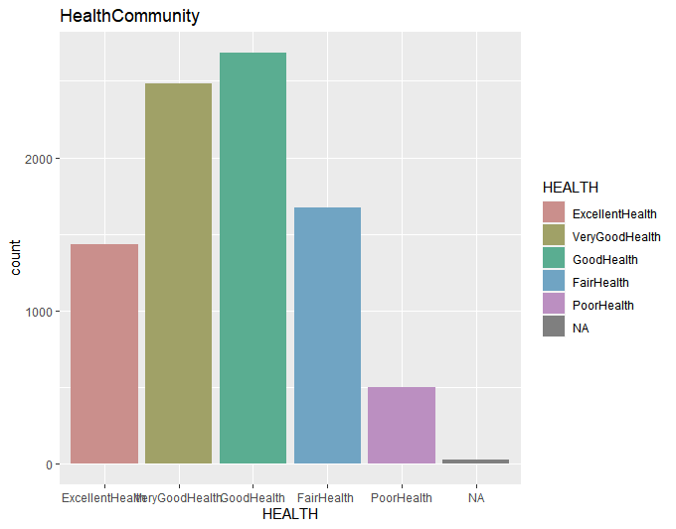

Health status by groups from CHS2019.

We also noticed that making small area estimations without expanding sample size is to apply indirect estimators that use auxiliary population data about the variable of interest from related areas and/or time periods. The race factors have been verified by three different variables asking somewhat the same question about identity to induce triple verifications (newrace6, newrace6_b, and other subgroups named “ demog135r” , “ demog183”, and “ nativeindig” = Native American Heritage. (CHS 2019, pg24). We assume those are indirect estimators that have been applied to obtain estimates at various geographic units; however, there are limitations in using these data for program evaluation or to evaluate changes over time.

Literature review:

1. **Fleischer NL, Henderson AK, Wu YH, Liese AD, McLain AC. Disparities in Diabetes by Education and Race/Ethnicity in the U.S., 1973-2012. Am J Prev Med. 2016 Dec;51(6):947-957. doi: 10.1016/j.amepre.2016.06.019. Epub 2016 Aug 21. PMID: 27554365.**

The objective of this review was to decide whether inconsistencies in diabetes, education and race/nationality have expanded over the long haul, and assuming there are contrasts by sex and birth accomplice. The National Health Interview Survey targeted adults, both men and women aged 25–84 years and focused on the prevalence of Type 2 diabetes mellitus among adults in the U.S. has more than doubled over the past 2 decades. Groups were split into shorts 1, 2, 3 and so on. Connections between education or race/identity and diabetes were altered by an ideal opportunity for individuals brought into the world before 1971, with more grounded impact change for women than men. Imbalances in diabetes commonness developed over the long haul, albeit the size of incongruities was more modest for the 1946-1970 partner. For instance, in 2005-2012, the hole in diabetes pervasiveness for women with the most noteworthy and least degrees of instruction was 12.7% for pre-1946 versus 7.9% for 1946-1970. Comparative patterns were seen for contrasts between non-Hispanic Whites and non-Hispanic Blacks or Hispanics. Results were uncertain for the most youthful companion. Also, Blacks, Hispanics, and Asians have up to twice the prevalence of diabetes compared with non-Hispanic whites. These differences in the country in race/ethnicity are only increasing. Evidence has suggested that gender and birth cohorts and education levels may modify socioeconomic disparities in diabetes. ( Fleischer and al, 2016). For example, the difference between Blacks and Whites was 4.0% in 1978–1984 and 9.8% in 2006–2012 for women, and 2.3% in 1978–1984 and 7.4% in 2006–2012 for men. Similar patterns were seen for Hispanic women and men compared with Whites, although the magnitude of the differences was slightly less. Differences between Asians and Whites only emerged in 2006–2012 for Women and men in Cohort 1. For women, differences between whites and blacks or Hispanics started to emerge in 1992–1998, with the greatest differences seen in 2006–2012 Asian women had lower diabetes prevalence than white women in the two earliest periods, and no differences later. The interaction between race/ethnicity and period was not statistically significant for men in Cohort 2 or women or men in Cohort 3. Please see image below. (complementary information is contained in Appendix)

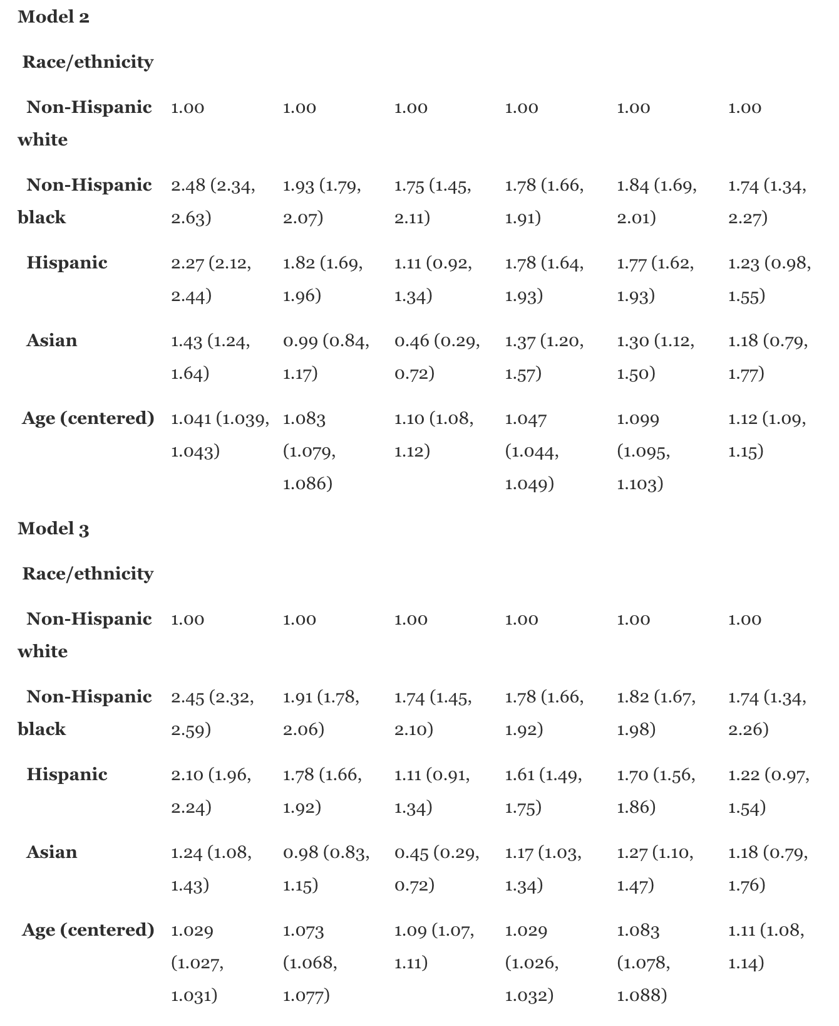

Our study demonstrated inconsistencies are obvious. More modest contrasts in community support and neighborhoods show huge primary changes related to upbringing(e.g., Social equality development, expanded instructive and monetary freedoms) may have helped later ages.

2. **Duncan DT, Ruff RR, Chaix B, Regan SD, Williams JH, Ravenell J, Bragg MA, Ogedegbe G, Elbel B. Perceived spatial stigma, body mass index and blood pressure: a global positioning system study among low-income housing residents in New York City. Geospat Health. 2016 May 31;11(2):399. doi: 10.4081/gh.2016.399. PMID: 27245795.**

Duncan and al. have evaluated relationships between perceived spatial stigma, body mass index (BMI), and blood pressure among a sample of low-income housing residents in New York City (NYC). Data come from the community-based NYC Low-income Housing, Neighborhoods and Health Study. generalisability and capacity to draw relationship between spatial shame and estimated cardiovascular wellbeing results. The essential goal of this review was to assess connections between demographics, weight record (BMI), and pulse among low-pay lodging inhabitants in New York City (New York City). Authors ran a cross sectional investigation with study information, which remembered the four things for spatial disgrace, too unbiasedly estimated BMI and circulatory strain information (insightful n=116; 96.7% of the complete example). Authors used multivariable regression models including individual-level age, race/identity, education level, work status, absolute family pay, neighborhood. Participants reported living terrible neighborhoods with the prevalence of higher BMI (B=4.2, 95%CI: - 0.01, 8.3, P=0.051), a (B=13.2, 95%CI: 3.2, 23.1, P=0.01) and diastolic circulatory strain (B=8.5, 95%CI: 2.8, 14.3, P=0.004). Also, participants who detailed living in a space with a terrible neighborhood notoriety had expanded danger of weight/overweight [relative danger (RR)=1.32, 95%CI: 1.1, 1.4, P=0.02) and hypertension/prehypertension (RR=1.66, 95%CI: 1.2, 2.4, P=0.007). The majority of participants were mainly from high neighborhood percent Hispanics and Blacks and neighborhood median household income. We then ran this regression with Healthcare coverage as a dependent variable.

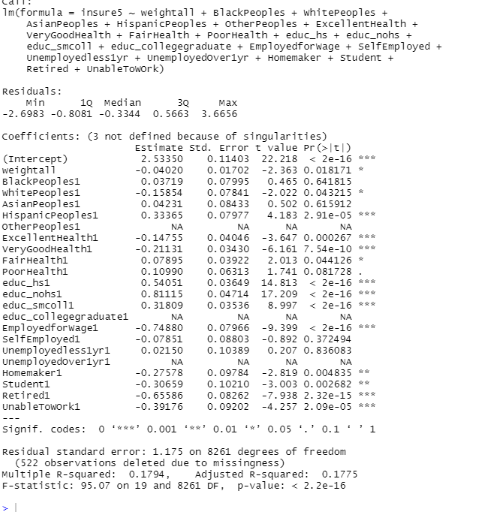

Let’s look at this regression above: We want to demonstrate the relationship between Body Mass Index (BMI) and Healthcare coverage are dependent on Income and Work Opportunity. Money buys Healthcare coverage or poverty determines eligibility to Government-supported healthcare (Medicaid) . Money buys food and therefore determines your food habits.

**Relationship between Health Insurance, Employment, Nutrition and BMI**

============================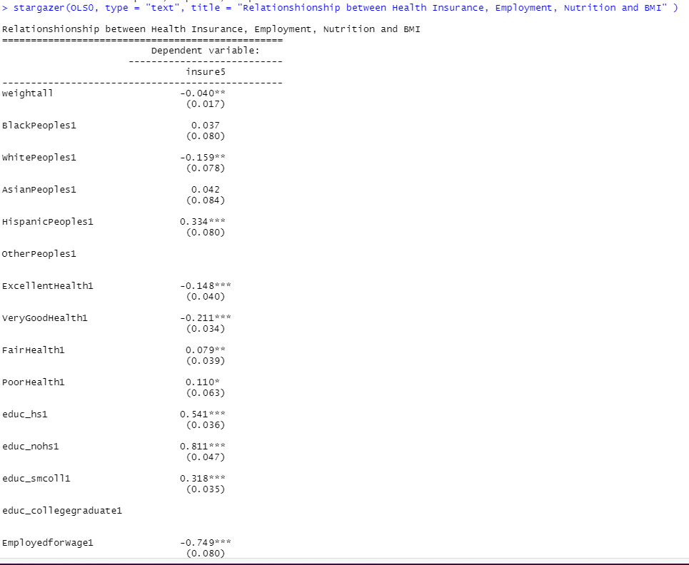=====================

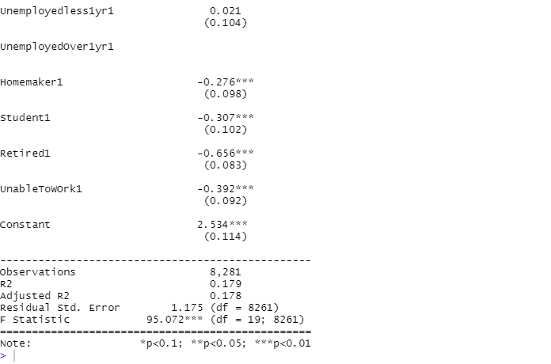

Now let's look at the impact poverty line based on Zip Codes in relationship with Community support across the City, We want to demonstrate that social upbringing can be deterred by poverty levels, thus one's own income. However, if a supportive community composed of Blacks, Whites, Hispanics or Asians is very willing to provide community service, that may generate positive outcomes in the future as Groups grow up and get educated. Then, they will enter the labor market, get earnings in order to uplift their health conditions. Community service may mean also facilitating social programs that enroll low-income families in Medicaid, or job services to fight unemployment.

> OLS1 <- lm(imputed_neighpovgroup4_1418 ~ weightall + insure5 + BlackPeoples + WhitePeoples + AsianPeoples + HispanicPeoples +OtherPeoples + ExcellentHealth + VeryGoodHealth + FairHealth + PoorHealth + educ_hs + educ_nohs + educ_smcoll + educ_collegegraduate + EmployedforWage + SelfEmployed + Unemployedless1yr + UnemployedOver1yr + Homemaker + Student + Retired + UnableToWOrk)

> summary(OLS1)

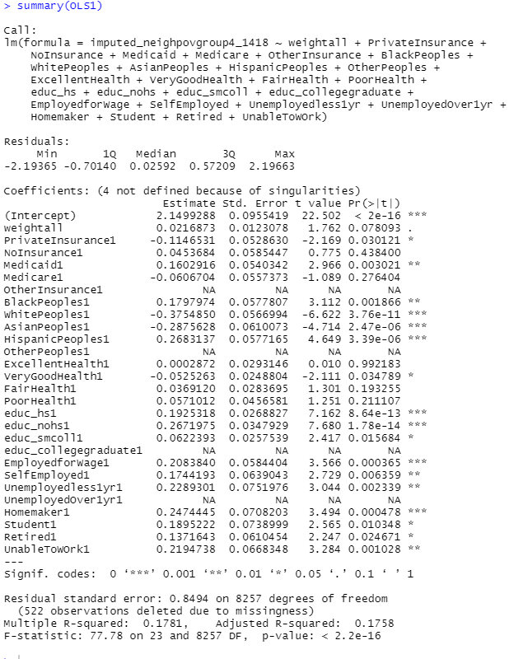

We can see that all social groups seem to be supportive, We also notice that mainly peoples employed for wage are relevant to this assumption, because they may qualify for Healthcare through their workplace We also see that Homemakers definitely qualify for Medicaid which is also significant.

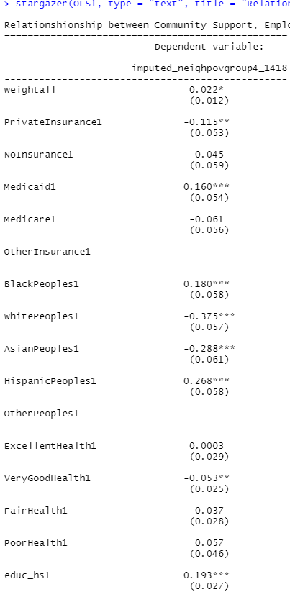

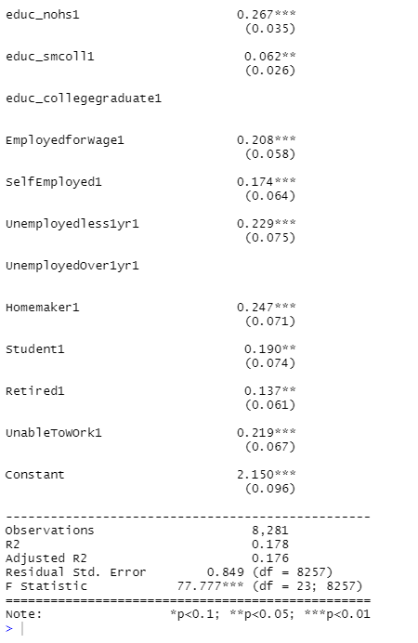

There is certainly a relationship between Income Levels, job opportunities and healthcare coverage.

glm(formula = WealthyGroup ~ weightall + insure5 + BlackPeoples +

WhitePeoples + HispanicPeoples + AsianPeoples + ExcellentHealth +

VeryGoodHealth + FairHealth + PoorHealth + +educ_hs + educ_smcoll +

educ_collegegraduate + EmployedforWage + SelfEmployed + Homemaker +

Student + Retired, family = binomial)

Deviance Residuals:

Min 1Q Median 3Q Max

-1.5013 -0.6688 -0.3606 -0.1534 3.2792

Coefficients:

Estimate Std. Error z value Pr(>|z|)

(Intercept) -1.91279 0.29053 -6.584 4.59e-11 ***

weightall -0.13004 0.04015 -3.239 0.00120 **

insure5 -0.45620 0.03243 -14.068 < 2e-16 ***

BlackPeoples1 -0.29844 0.18049 -1.653 0.09824 .

WhitePeoples1 0.56529 0.17184 3.290 0.00100 **

HispanicPeoples1 -0.55468 0.18422 -3.011 0.00260 **

AsianPeoples1 -0.38140 0.19054 -2.002 0.04532 *

ExcellentHealth1 0.52272 0.08807 5.935 2.93e-09 ***

VeryGoodHealth1 0.40206 0.07590 5.297 1.18e-07 ***

FairHealth1 -0.33408 0.11117 -3.005 0.00265 **

PoorHealth1 -0.19782 0.18640 -1.061 0.28858

educ_hs1 -0.03568 0.18623 -0.192 0.84807

educ_smcoll1 0.34791 0.17822 1.952 0.05092 .

educ_collegegraduate1 1.24688 0.16903 7.377 1.62e-13 ***

EmployedforWage1 0.89940 0.13768 6.532 6.47e-11 ***

SelfEmployed1 0.75013 0.16115 4.655 3.24e-06 ***

Homemaker1 0.46977 0.21616 2.173 0.02976 *

Student1 0.58467 0.21558 2.712 0.00669 **

Retired1 0.75304 0.14456 5.209 1.90e-07 ***

---

Signif. codes: 0 ‘***’ 0.001 ‘**’ 0.01 ‘*’ 0.05 ‘.’ 0.1 ‘ ’ 1

(Dispersion parameter for binomial family taken to be 1)

Null deviance: 8834.6 on 8280 degrees of freedom

Residual deviance: 6894.9 on 8262 degrees of freedom

(522 observations deleted due to missingness)

AIC: 6932.9

Number of Fisher Scoring iterations: 6

In this regression model, we can definitely see that Whites, Asians tend to be beneficiaries of very good HealthCare coverage and then maintain a very healthy life. There is a strong relationship showing the level of significance. Also we see that a high level of education is a parameter of Wealthy Group whose earnings are correlated along with Good healthcare and Private insurance. Public insurance is not expected to be a consumer’s choice for working adults between the ages of 18 and 64.

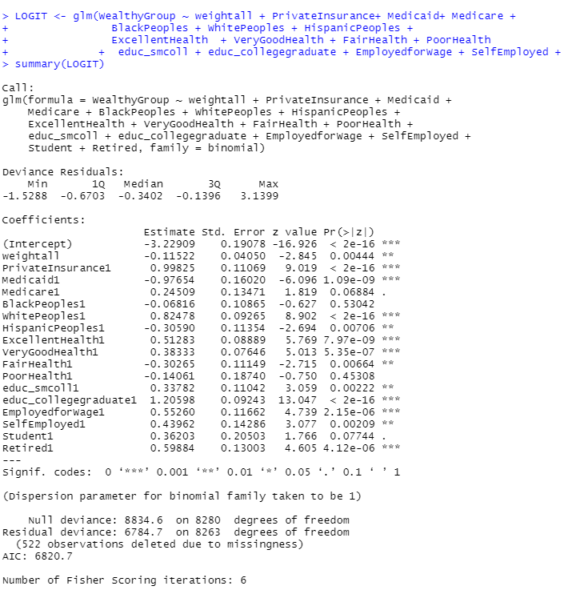

According to our argument, we also notice that income level, high level earnings (Wealthy Group) are based on high education and work status matter to health coverage. If people have high earnings, they can definitely buy private insurance. Here the regression demonstrates that Whites usually are carriers of private insurance, high degree and a good health status.

The correlation below demonstrates a relationship between the Community support and their poverty levels in their neighborhoods. It also shows that the food habits are based on support received either by social services or the collective willingness to support each other. As per CHS2019 did not specify Community activities that may relate to Health Conditions, we are just assuming that poor communities enjoy social programs to maintain a good health standing. However, if they're poor ( homemakers) or retired they can definitely qualify for Medicaid or Medicare to maintain their health standing. They all have a strong significance.

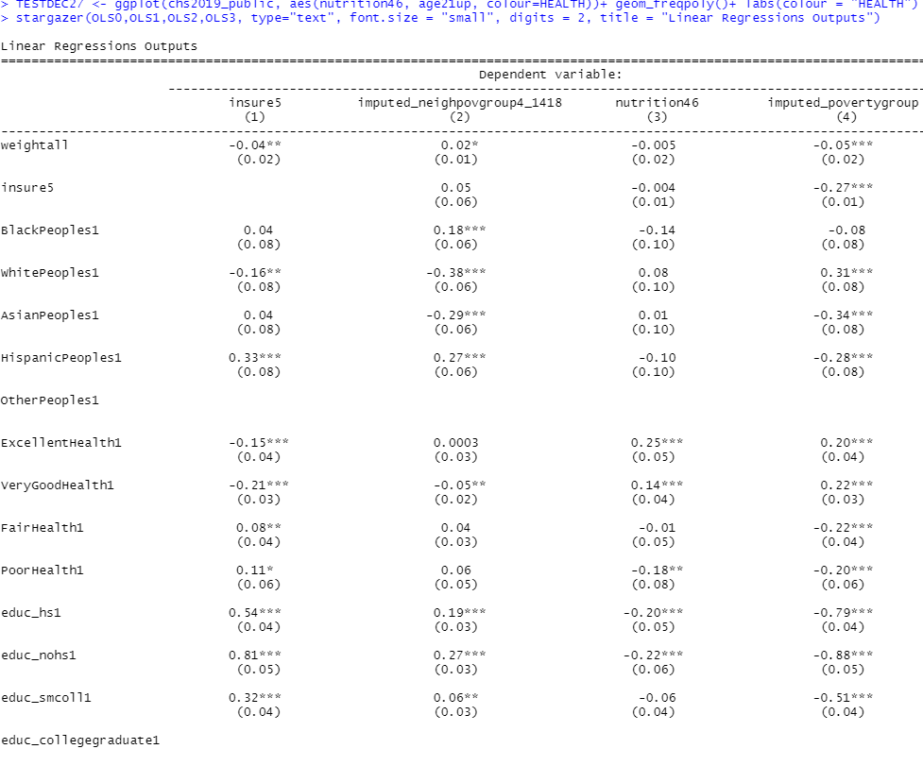

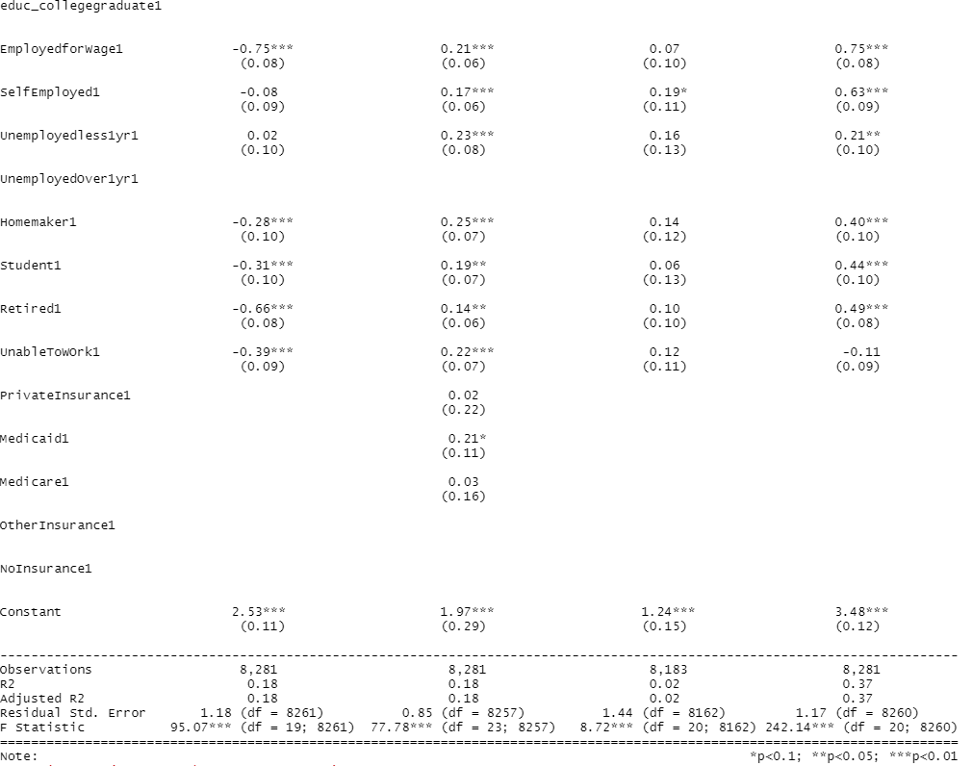

We see that out residents with Private insurance coverage are more likely to cover their nutrition and watch their weight 75.84% have been vaccinated to the flu shot Poverty levels and race are closely related based on this relationship with OLS3. We can see that Optimal health stock/incentives will decline as the person ages if the depreciation rate of health increases as a person ages. We can see that race matters to our population sample. Benefits of good health are greater for high wage workers in NYC so they demand higher optimal health facilitations such as Medicaid, Medicare. The more educated people are, the less costly it is to generate health resulting in a higher optimal health stock for these groups based on race, age and kinds of employment. Individuals will allocate resources in order to produce health capital in order to maintain their activity and health status and their job and earnings.

Johnson, K. (2020) stressed the need for food democracy in New York City. Johnson studied the principles of food democracy present in the successful process of adoption of the 2006 NYC trans fat policy addressed nutrition-related health. Food democracy is a contemporary food system and policy approach with potential for public health benefits in reducing nutrition-related health disparities. In this paper, participants expressed outrage over perceived lack of concern for public health and poor collaboration by industry. (2020) Participants also argued that Heart disease and obesity are some of the effects of trans fats … that plague the black community of NYC. Indeed, Johnson mentioned that a 2004 report by the NYC Department of Health and Mental Hygiene “found minorities more likely to live in poverty and die of nutrition-related non-communicable diseases such as heart disease, cancer, diabetes, stroke and high blood pressure ( Karpati, Kerker and Mostashari, 2008). These health disparities demanded an approach that addressed food environments and drivers of nutrition-related non-communicable disease beyond individual behaviours by community education and mentorship.

Conclusion

The CHS2019 was used to demonstrate our hypothesis that Healthcare coverage is dependent on Income and levels of education. Good education will certainly guarantee good paying jobs with high earnings. We saw that the social groups Blacks, Asians, Whites and Hispanics are statistically significant based on the dependent variables used. We noticed that Whites have access to good insurance plans ( Private Insurance) where Hispanics and Blacks are more into Medicaid and NoInsurance. Retired and Veterans may enjoy other insurance based on years of services The article speaks upon a major health care policy issue in the United States of a growing population without insurance. It tackles the question of how health insurance coverage affects the likelihood of an individual seeking medical care and how does health insurance affect health care expenditures. This decision is also endogenous and people who have a greater need for health care have more incentive to buy health insurance. Surveys of households, employers, and medical providers are conducted to collect information on health care expenditures and health insurance coverage, as well as demographic and socioeconomic characteristics. We focused on the obese population because it is a growing population that might have different health care needs. They focused on individuals who are employed because insurance is often linked with employment in the country. The subgroup after filtering them out with these characteristics consists of 2,771 individuals. The explanatory variables in this paper are demographics, socioeconomic status, and health-related characteristics. The chosen demographics are age, gender, race/ethnicity, borough, years of education, income, occupation class, and industry insurance rates are included as socioeconomic characteristics. Meanwhile, CHS2019 also discusses social groups by origins of immigrants or background lineage. That was not our focus. As we already know, immigrants participate in the revenue of New York City. The Labor force did not designate mixed-status families or legal status of immigration. Health insurance coverage varies strongly by immigration status. In conclusion, we found that insurance has a substantial effect on both utilization and expenditures. OUr regressions suggest that having private insurance coverage increases the likelihood of seeking health care by about 15 percentage points. The parametric estimation predicts the level of expenditures to increase by 125% if universal insurance is given, while semiparametric estimation predicts an increase of 48%. Other marginal effects are also worth noting. Education is an important factor in every health care decision, and hence improving health literacy on Body Mass Index is an important solution to educate the obese population. Poor New Yorkers, as well as African-American and Hispanic New Yorkers, bear a disproportionate burden of illness and premature death.

References:

Ashley M. Fox, Devin M. Mann, Michelle A. Ramos, Lawrence C. Kleinman, Carol R.

Horowitz, The Influence of Physical Activity on Obesity and Health "Barriers to Physical

Activity in East Harlem, New York", Journal of Obesity, vol. 2012, Article ID 719140, 8 pages,

2012. https://doi.org/10.1155/2012/719140

Retrieved from http://www.hindawi.com/journals/jobe/2012/719140/abs/

Bi, Q., He, F., Konty, K., Gould, L. H., Immerwahr, S., & Levanon Seligson, A. (2020). ZIP Code-Level Estimates from a Local Health Survey: Added Value and Limitations. *Journal of urban health : bulletin of the New York Academy of Medicine*, *97*(4), 561–567. [https://doi.org/10.1007/s11524-020-00423-](https://doi.org/10.1007/s11524-020-00423-z)

Chan Shen; Determinants of Health Care Decisions: Insurance, Utilization, and Expenditures. The Review of Economics and Statistics 2013; 95 (1): 142–153. doi: https://doi.org/10.1162/REST_a_00232

Feagin, Joe R. and Hernan Vera. 1995. White Racism: The Basics. New York: Routledge. Goyette, Kimberly A. and Yu Xie. 1999. “Educational Expectations of Asian American Youths: Determinants and Ethnic Differences.” Sociology of Education 72(1):22–36.

Fleischer NL, Henderson AK, Wu YH, Liese AD, McLain AC. Disparities in Diabetes by Education and Race/Ethnicity in the U.S., 1973-2012. Am J Prev Med. 2016 Dec;51(6):947-957. doi: 10.1016/j.amepre.2016.06.019. Epub 2016 Aug 21. PMID: 27554365.

Gloria M. Reeves, Teodor T. Postolache, Soren Snitker, Childhood Obesity and Depression: Connection between these Growing Problems in Growing Children: Int J Child Health Hum Dev. Author manuscript; available in PMC 2008 Oct 16. Published in final edited form as: Int J Child Health Hum Dev. 2008 Aug; 1(2): 103–114. PMCID: PMC2568994

Retrieved from <http://www.ncbi.nlm.nih.gov/pmc/articles/PMC2568994/>

Johnson-Lans, S., Bellemore, F. & Chen, LP.M. Gender and race as factors in health care utilization. International Advances in Economic Research 3, 123 (1997). https://doi.org/10.1007/BF02295009

Johnson, K. (2020). Food democracy, health disparities and the New York City trans fat policy. Public Health Nutrition, 23(4), 738-746. doi:10.1017/S1368980019003306

Schansberg, D. Eric. “The Economics of Health Care and Health Insurance.” The Independent Review, vol. 18, no. 3, Independent Institute, 2014, pp. 401–20, <http://www.jstor.org/stable/24563243>.

Poverty among Asian Americans in the 21st Century. Author(s): Isao Takei and Arthur Sakamoto

Source: Sociological Perspectives, Vol. 54, No. 2 (Summer 2011), pp. 251-276

Published by: Sage Publications, Inc.

Opioid Crisis ( 2017) U.S Department of Health and Human Services. ( Source:

https://www.hhs.gov/opioids/about-the-epidemic/index.html).

- Solutions to opiod crisis ( HRSA, june 2019): https://www.hrsa.gov/opioids

- National Institute of Drug Abuse - Advancing Addicition Science ( June 2016): Fentanyl

Health Disparities in New York City: A Report from the New York City Department of Health and Mental Hygiene:https://www.commonwealthfund.org/sites/default/files/documents/___media_files_publications_other_2004_jul_health_disparities_in_new_york_city_karpati_disparities_pdf.pdf

Appendix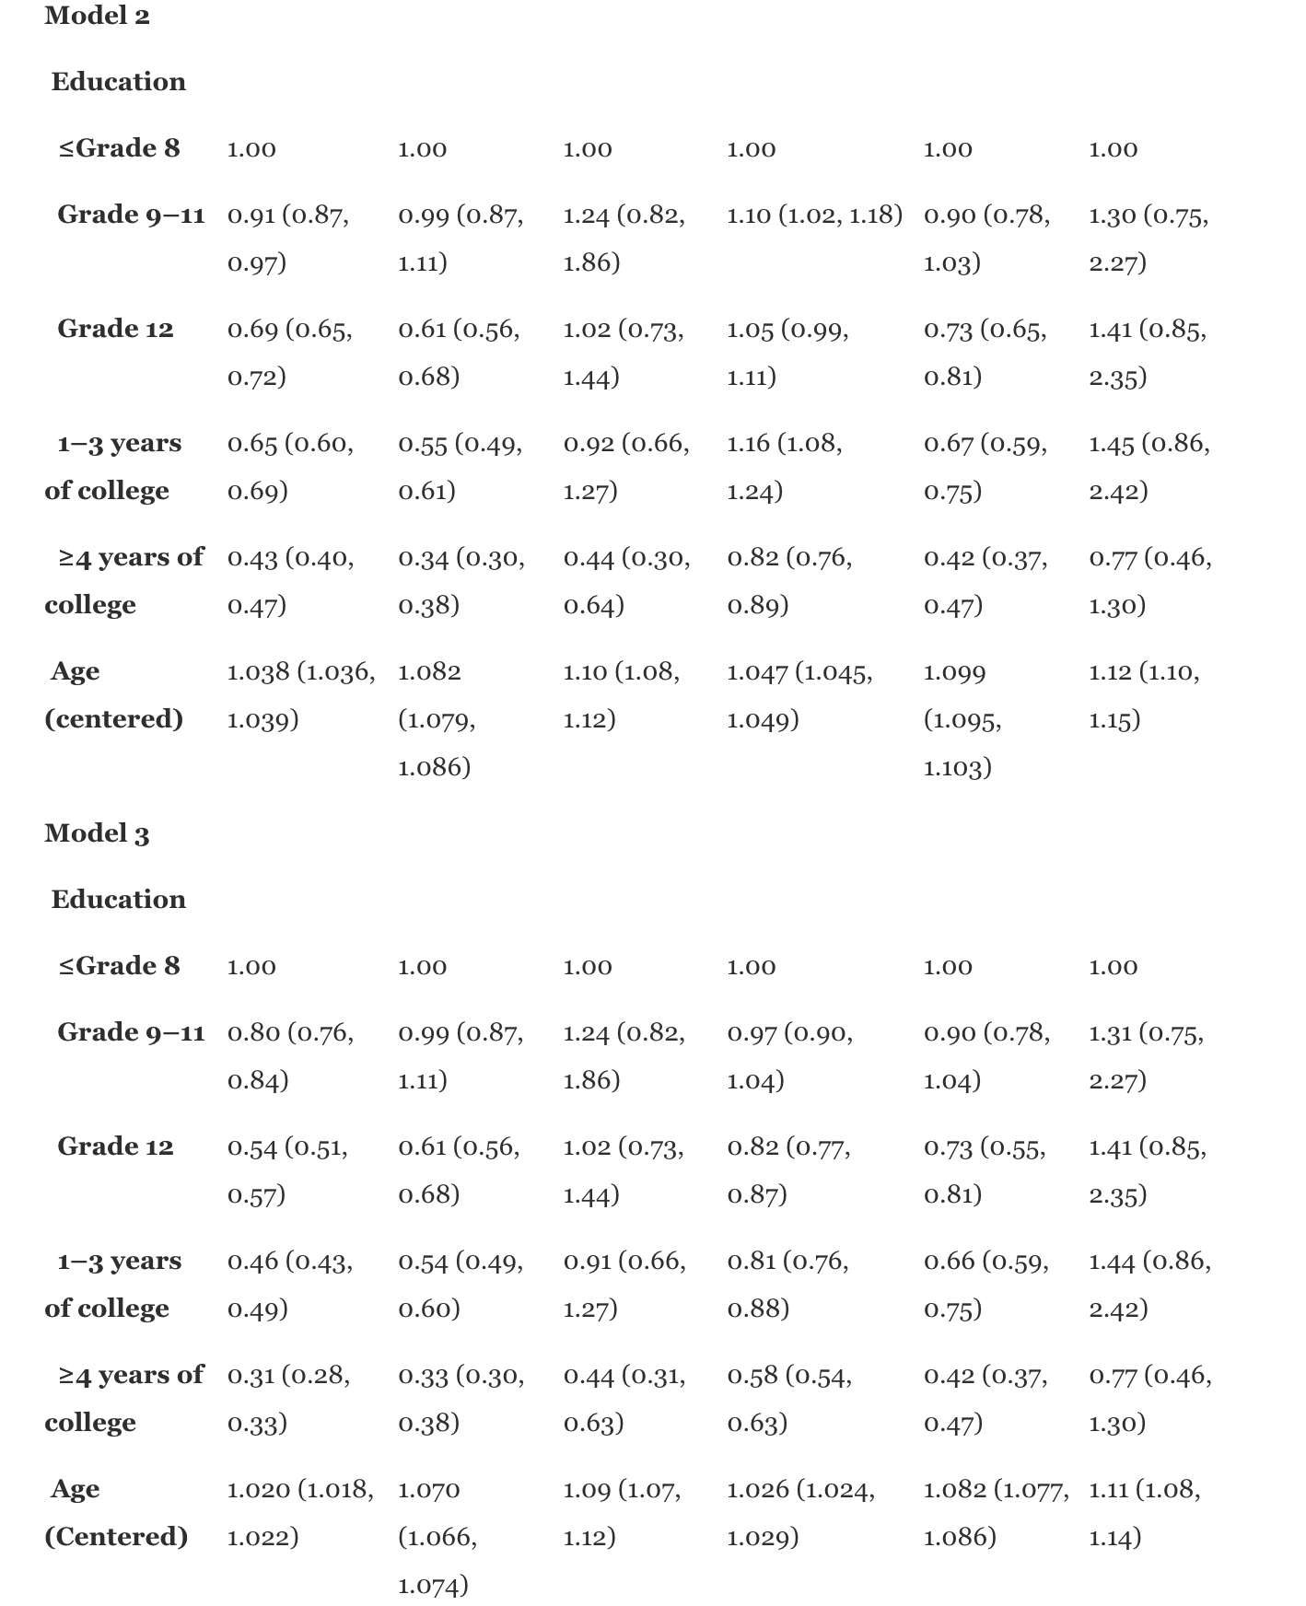: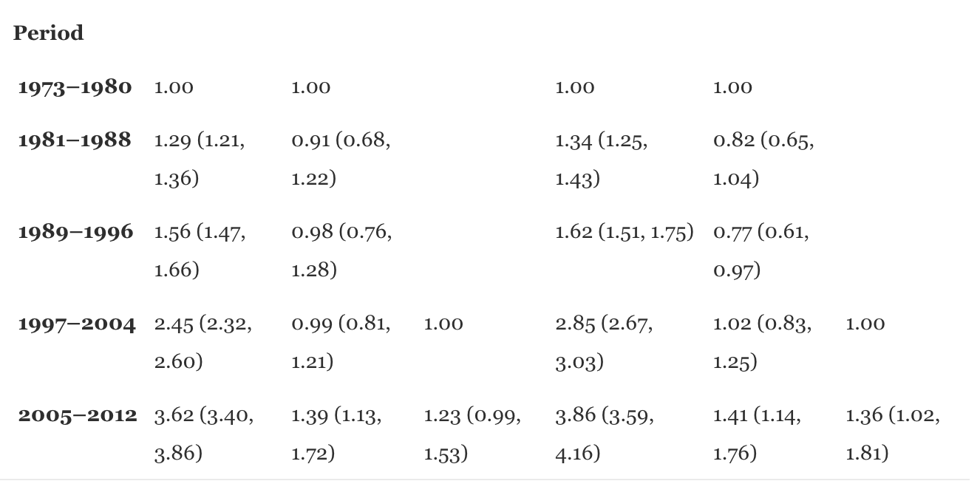

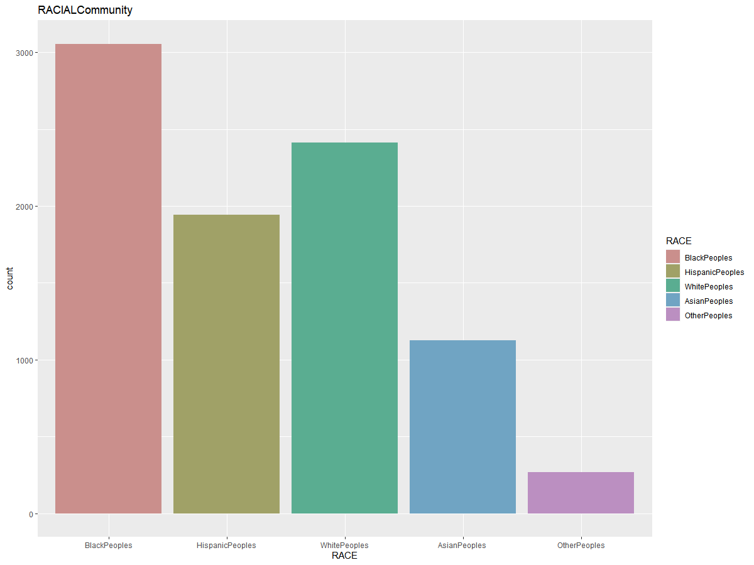

Copyright: Kouakou.H, Cisse, S. and Andrade, J.

